|  | **ASSIGNMENT 4** | |
| --- | --- | --- |
|  |  |  |
| **Date** |  | **1 November 2022** |
| **Team ID** |  | **PNT2022TMID53567** |
| **Project Name** |  | **Smart Waste Management** |
|  |  | **System for Metropolitan Cities** |

**QUESTION:**

**Write code and connections in wokwi for ultrasonic sensor. Whenever distance is less than 100 cms send "alert" to ibm cloud and display in device recent events.**

CODE:



#include <WiFi.h> #include <PubSubClient.h>



void callback(char* subscribetopic, byte* payload, unsigned int payloadLength);



//-------credentials of IBM Accounts------



#define ORG "u9pz01"//IBM ORGANITION ID #define DEVICE_TYPE "ultrasensor"//Device type mentioned in ibm watson IOT Platform



#define DEVICE_ID "123"//Device ID mentioned in ibm watson IOT Platform



#define TOKEN "12345678" //Token String data3;



char server[] = ORG



".messaging.internetofthings.ibmcloud.com";



char publishTopic[] = "iot-



2/evt/Data/fmt/json";



char subscribetopic[] = "iot-2/cmd/test/fmt/String";



char authMethod[] = "use-token-auth"; char token[] = TOKEN;



char clientId[] = "d:" ORG ":" DEVICE_TYPE ":" DEVICE_ID;



WiFiClient wifiClient;



PubSubClient client(server, 1883, callback ,wifiClient);



const int trigPin = 5; const int echoPin = 18; #define SOUND_SPEED 0.034 long duration; float distance;



void setup() {



Serial.begin(115200);



pinMode(trigPin, OUTPUT);



pinMode(echoPin, INPUT);



wificonnect();



mqttconnect();



}



void loop()



{



digitalWrite(trigPin, LOW); delayMicroseconds(2); digitalWrite(trigPin, HIGH); delayMicroseconds(10); digitalWrite(trigPin, LOW); duration = pulseIn(echoPin, HIGH);





distance = duration * SOUND_SPEED/2;



Serial.print("Distance (cm): ");



Serial.println(distance);



if(distance<100)



{



Serial.println("ALERT!!");



delay(1000);



PublishData(distance);



delay(1000);



if (!client.loop()) {



mqttconnect();



}



}



delay(1000);



}



void PublishData(float dist) { mqttconnect();



String payload = "{\"Distance\":"; payload += dist;



payload += ",\"ALERT!!\":""\"Distance less



than 100cms\"";



payload += "}";



Serial.print("Sending payload: "); Serial.println(payload);



if (client.publish(publishTopic, (char*)



payload.c_str())) {



Serial.println("Publish ok");



} else {



Serial.println("Publish failed");



}



}



void mqttconnect() {



if (!client.connected()) {



Serial.print("Reconnecting client to "); Serial.println(server);



while (!!!client.connect(clientId, authMethod, token)) {



Serial.print(".");



delay(500);



}



initManagedDevice();



Serial.println();



}



}



void wificonnect()



{



Serial.println();



Serial.print("Connecting to "); WiFi.begin("Wokwi-GUEST", "", 6); while (WiFi.status() != WL_CONNECTED) { delay(500);



Serial.print(".");



}



Serial.println("");



Serial.println("WiFi connected");



Serial.println("IP address: ");



Serial.println(WiFi.localIP());



}



void initManagedDevice() {



if (client.subscribe(subscribetopic)) { Serial.println((subscribetopic)); Serial.println("subscribe to cmd OK");



} else {



Serial.println("subscribe to cmd FAILED");



}



}



void callback(char* subscribetopic, byte* payload, unsigned int payloadLength) {



Serial.print("callback invoked for topic: "); Serial.println(subscribetopic);



for (int i = 0; i < payloadLength; i++) {



//Serial.print((char)payload[i]);



data3 += (char)payload[i];



}



Serial.println("data: "+ data3);



data3="";



}

**SCHEMATIC/CIRCUIT DIAGRAM:**

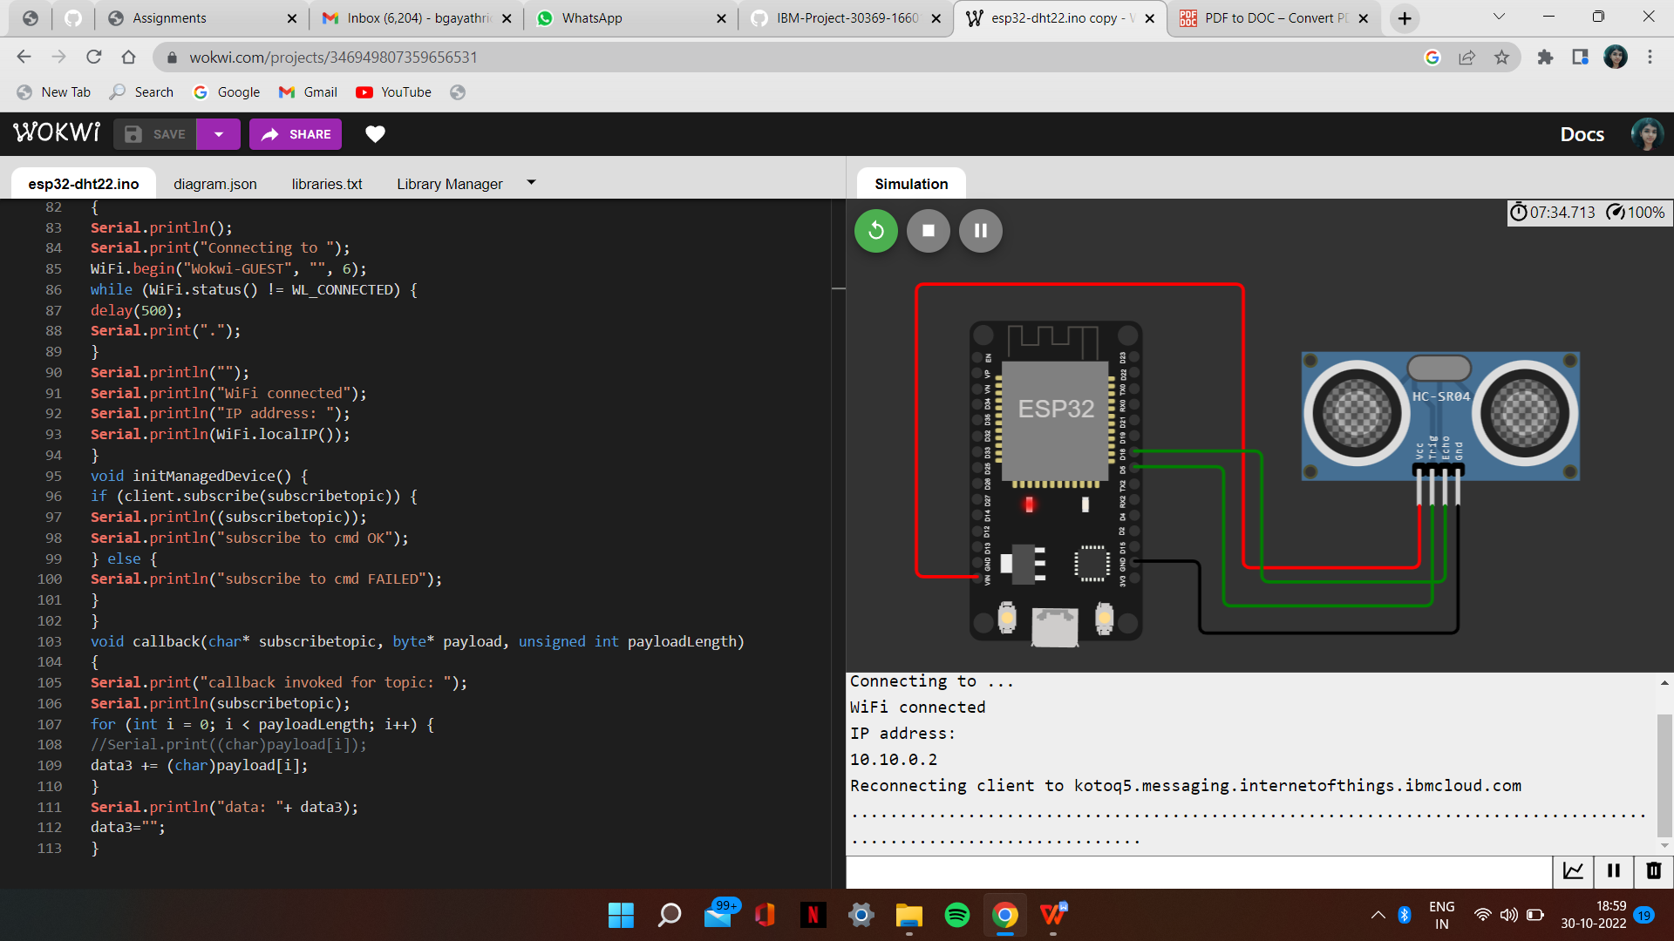

**IBM CLOUD OUTPUT:**

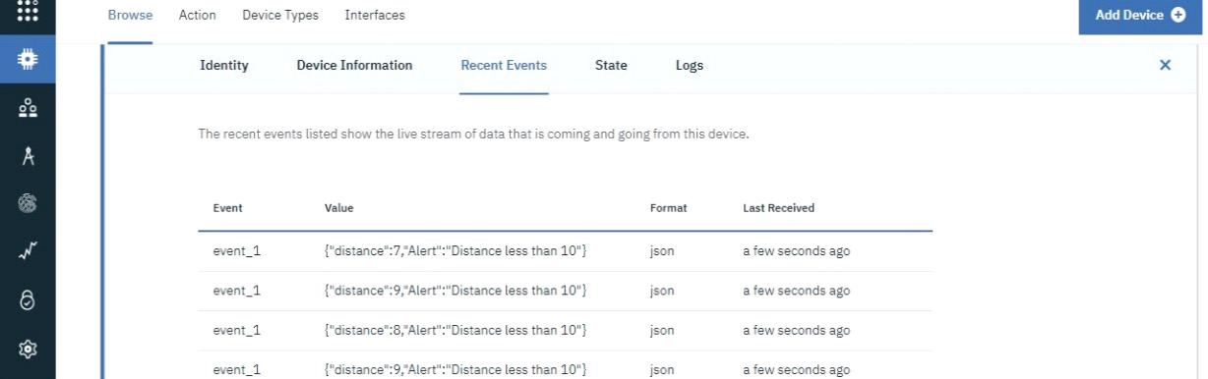

WOKWI LINK:

https://wokwi.com/projects/347143360368083539